Mobile WSDL and RESTFUL services:

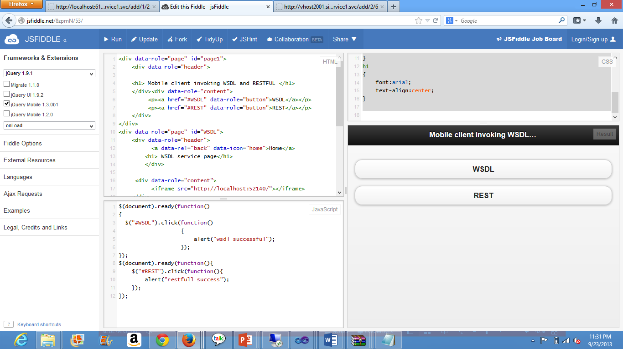

1. Above is the display of the mobile jquery application for wsdl and restful webservices. This is created to connect through mobile clients to use the webservices for various calculator operations.

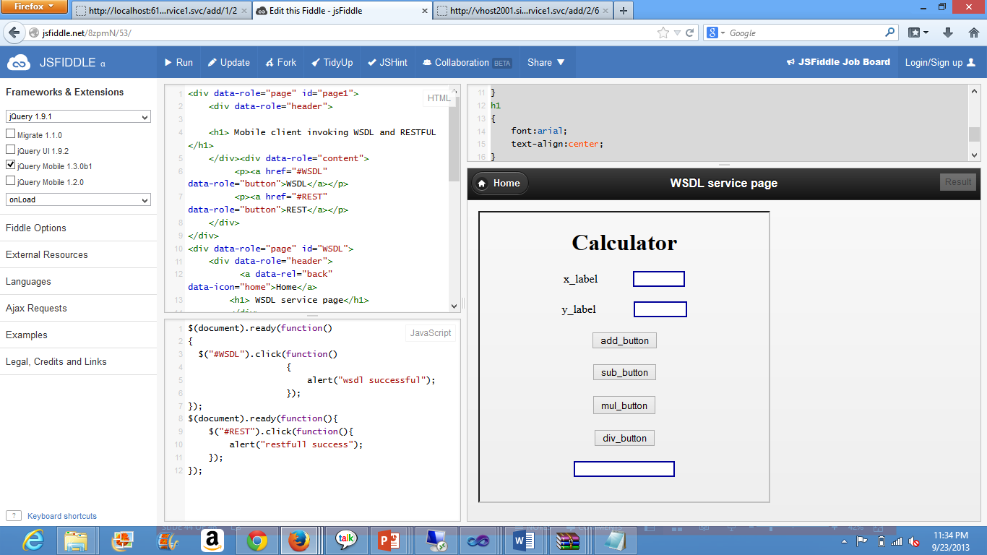

1. On clicking the WSDL it opens the calculator application that is designed using the wsdl. Wsdl application is created and is deployed at the cloud. Hence it is capable of getting retrieved in mobile web application.

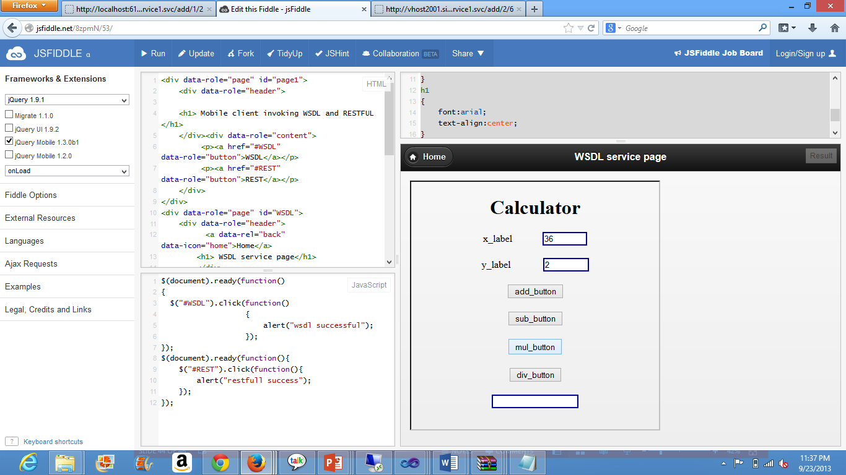

1. Values for x and y are entered as intended by the user. X as 36 and y as 2 and the intended operation is multiplication.

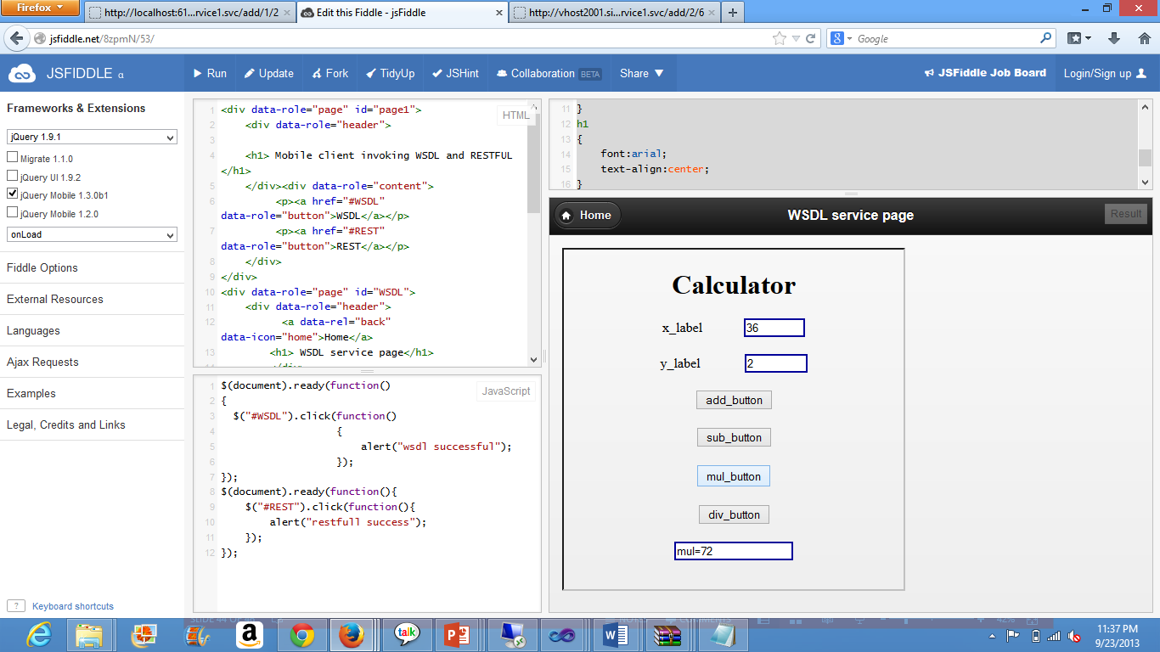

1. Output that is obtained is shown in the result label.

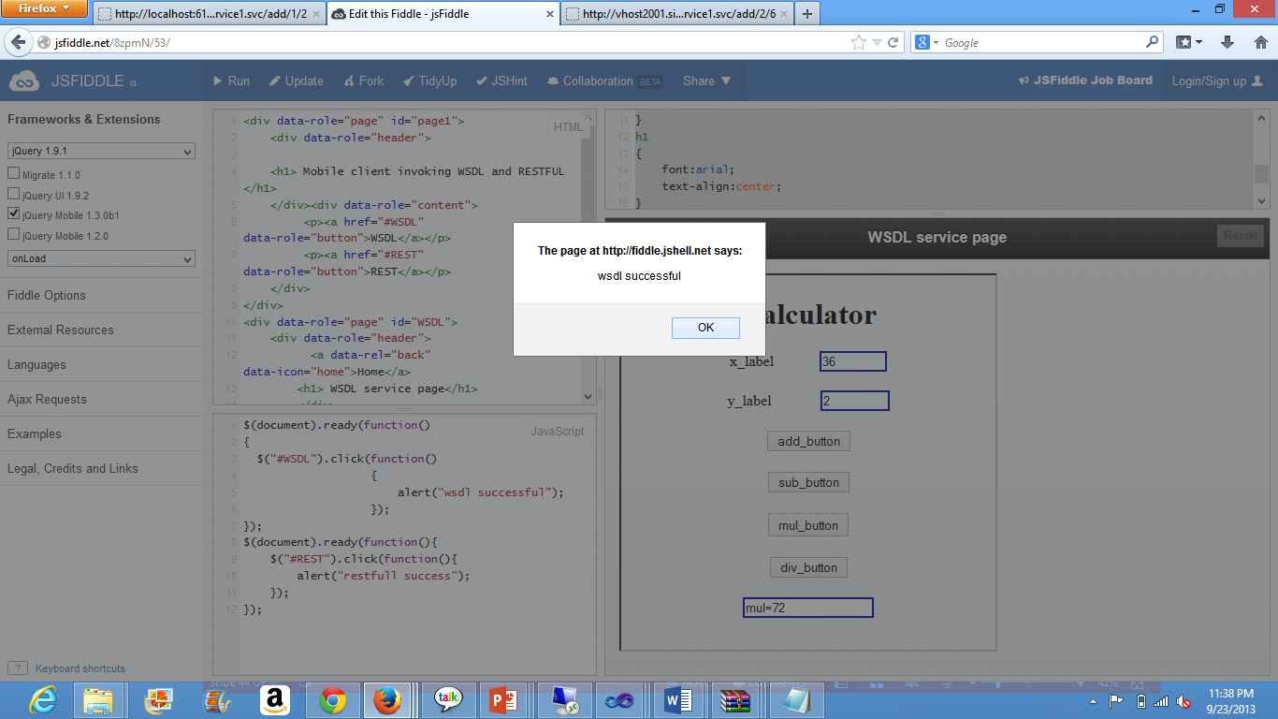

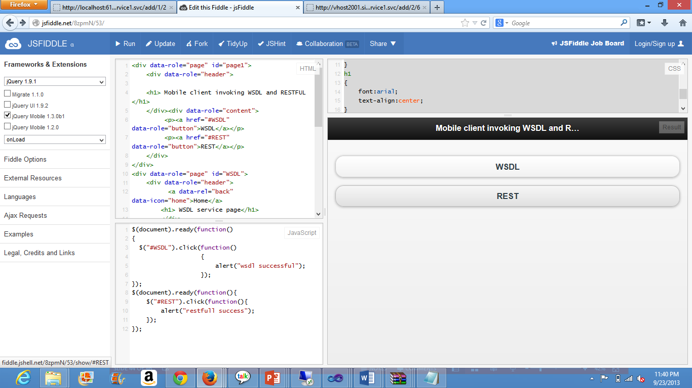

1. Going back to home shows the home page again.

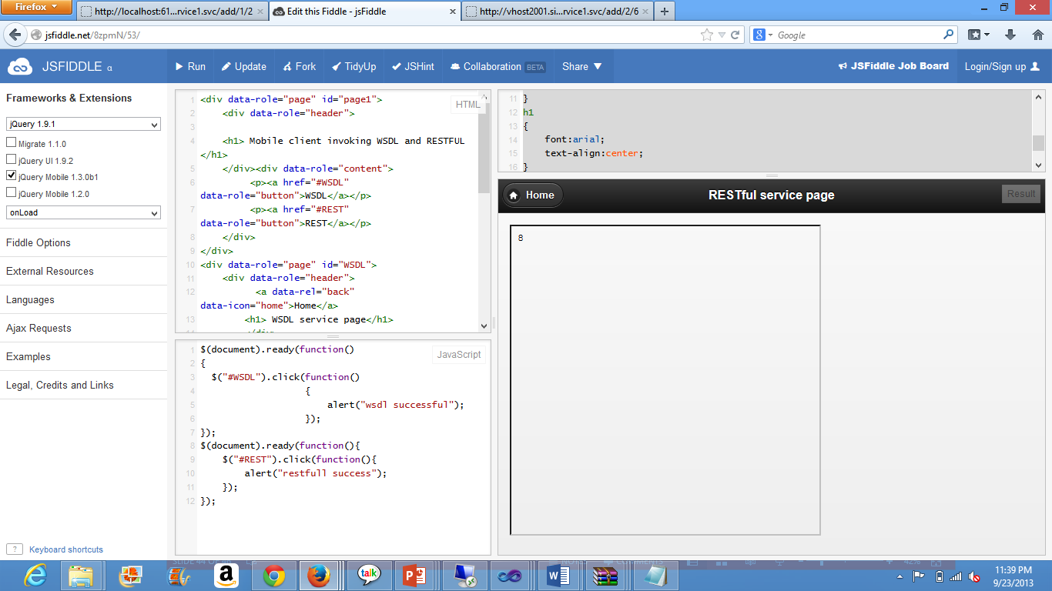

1. On clicking RestFul the intended output of addition of 2 and 6 as it is declared in the URL it gets displayed.

